Revelation 1 (Part 2)
Revelation – a book about radical discipleship
We begin with Revelation 1:9.
⁹ I, John, your brother and fellow partaker in the tribulation and kingdom and perseverance which are in Jesus, was on the island called Patmos, because of the word of God and the testimony of Jesus. (Rev. 1:9 NAS)
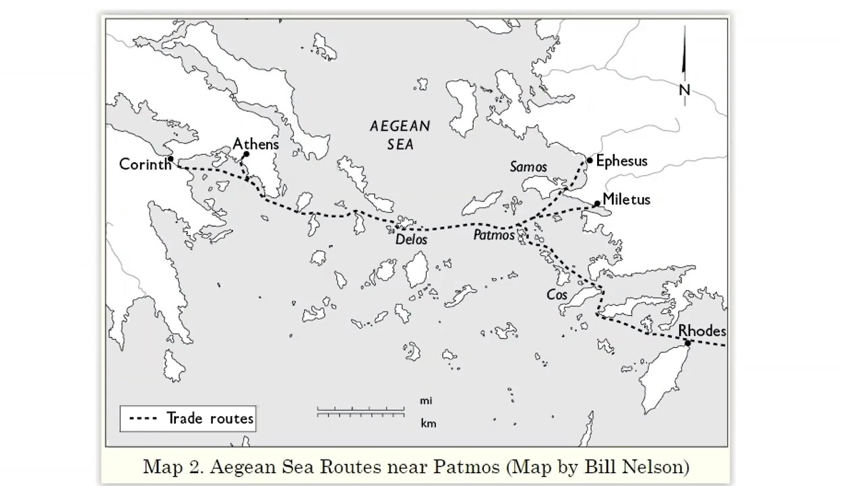
You will see here in the map where Patmos is. It is a very tiny island, only 10 miles by 5 miles. We are so used to thinking, at least in the past, I was told, that John was sent to a labor camp. Actually, that is not supported by archaeology. Nobody knows if this is the case. It could be just a banishment to someplace on that island, but there was no talk about a labor camp. So basically, he was there under banishment and was not allowed to leave the island.
Every time we come to Revelation, we have to remember God’s grand plan. What is Revelation all about? There are many things in Revelation that scholars disagree, but one thing that has a broad consensus is that this book is about radical discipleship. We are not just talking about discipleship but radical discipleship because we are placed in a situation where we either stand or fall; there is no in-between. Either we abide by the values of God’s Kingdom or the values of this world; there is no compromise. You cannot live a Christian life while sitting on the fence which means you cannot decide exactly where to put your entire weight on. So it is a clear call to live faithfully to Jesus and Yahweh.
Now we have to ask why is there a message of radical discipleship in Revelation? Can we look for a summary statement? It is said that if we know a subject well enough, we should be able to summarize in one sentence. So if you want to know what Revelation is aiming at, maybe we can turn to Paul. Let us look at the summary statement.
God’s secondary purpose – to unite all things under Christ
Ephesians 1:9-10
⁹ making known to us the mystery of His will, according to His purpose which He set forth in Christ
¹⁰ as a plan for the fullness of times, to unite all things in him, things in heaven and things on the earth.
Paul said that God has made known to us the mystery of His will according to His purpose, which He set forth in Christ as a plan for the fullness of time (that means the last day), to unite all things in Christ, things in heaven and things on earth. Now “things on earth” will also include humanity. Everything will be united under His son. That is why we do not lay up treasures on earth as well as manage our time wisely. We have to understand God’s purpose: in the end, we will see Jesus when he appears on the last day, and it is he we will have to reckon with and give an account of how we have lived our lives.
By that time, all our earthly possessions, qualifications, and achievements amount to nothing. The only thing that matters is whether we have lived according to God’s purpose in Christ during our lifetime here on earth. The question is whether we have been pleasing to God. At the present moment, consider what we have done with our lives, where our heart is, and what we often think about. That is why we talk about radical discipleship because everything will be united in Christ. The division between heaven and earth will be gone when Jesus comes again. Actually, that is the penultimate plan. It is not the end yet, which means that this is the secondary purpose. Why do I say that?
1 Corinthians 15:26-28
²⁶ The last enemy to be destroyed is death.
²⁷ For God has put all things in subjection under His feet. But when it says, “All things are put in subjection,” it is plain that he is excepted who put all things in subjection under him.
²⁸ When all things are subjected to him, then the Son Himself will also be subjected to Him who put all things in subjection under him, that God may be all in all.
In verse 28, the penultimate goal is for God to unite all things under him, and the ultimate goal is that God may be all in all. All opposition will be removed in Christ, and everyone will be subject to him. Then Christ himself will be subjected to God. In the end, he will give all glory to Yahweh. Let’s move on to the next one.
The disciple denies himself and listens to God
Revelation 1:10,11,19
¹⁰ I was in the Spirit on the Lord’s day, and I heard behind me a loud voice like a trumpet,
¹¹ saying, “Write what you see in a book and send it to the seven churches: to Ephesus and to Smyrna and to Pergamum and to Thyatira and to Sardis and to Philadelphia and to Laodicea.”
¹⁹ “Write therefore the things that you have seen, those that are and those that are to take place after this.
We have in our hands the book of Revelation, which is in written form. We read this in v:11 and 19. John saw what he saw; we didn’t see anything. I say this because the emphasis on vision in the Church today has to be conveyed very carefully. We have the words of Revelation, which are an account of John’s vision. When it was written and subsequently read aloud, all the churches would be hearing the words. These words were eventually handed down for all posterity up to this day. We are still reading and hearing those words. How do we know whether this is real or not, or perhaps John was dreaming? John said he was in the Spirit on the Lord’s day, “in the spirit” could be alcohol, right? So maybe he drank too much and then started seeing things? This is certainly not the case. It depends on how you hear.
Revelation 1:3
Blessed is the one who reads aloud the words of this prophecy, and blessed are those who hear, and who keep what is written in it, for the time is near.
“If you hear and keep it,” there it says, “you will be blessed.” God will bless you. You will know what spiritual happiness is. You will know what it means to live under God’s pleasure, which means God is happy with you. If He is happy with us, then it is quite clear that you know the reality of God through those words. In other words, it is a challenge for us to experience the reality of God through obedience.
Going back to radical discipleship, how do you hear, as a disciple? It is important to see that the first thing Jesus taught us is to deny ourselves! If you deny yourself, then you are dying to the selfish part of us that is exerting our own will over against God’s will. For example, over the past few weeks, I have been experiencing insomnia. I wasn’t able to sleep until daybreak. I get to sleep a little and then get up again. Since I can’t sleep, I thought to myself, “Perhaps I will do some work till I am sleepy again.” When I started reading books or working on the Bible, my attentiveness was greatly reduced. I wasn’t able to read with understanding and kept reading the same line or paragraph. The result was that my productivity went way down. It was a daily struggle. I know I have to get work done because I have laid out for myself what I need to do. Because of insomnia, my mental alertness and receptivity were severely affected. I read on a website which says that it is important to get enough sleep because that is the key to work efficiency. So I discovered that if I don’t have enough sleep, I would not be receptive at all. Now let’s look at the next frame.
Matthew 13:14, 15
¹⁴ “Indeed, in their case the prophecy of Isaiah is fulfilled that says, ‘You will indeed hear but never understand; And you will indeed see but never perceive;
¹⁵ For this people’s heart has grown dull, and with their ears they can barely hear, and their eyes they have closed, lest they should see with their eyes and hear with their ears, and understand with their heart and turn, And I would heal them.’

I can identify with these verses when I had insomnia. I would listen to a lecture or sermon, and it had become a matter of “hear but never understand.” My ears could barely hear, and my eyes were closed. Why? Not enough sleep!
The Word of God will benefit us when we learn to die
We know that the Bible compares death to sleep. When we come to Yahweh and say, “I am ready to die today.” (You might recall the previous sermon on living sacrifice). When you do that, then the interference is gone. We have the clarity of vision, and our hearing becomes acute. I can now feel the difference because this recent week, I overcame that insomnia. Since the last message up to this day, I have been sleeping very well. When I get up early in the morning, ah, the mind is clear, and I am refreshed. In two hours, I was able to do quite a lot. I could go on for three or four hours with breaks in-between. In terms of efficiency, it was much better with sleep.
So we have to understand this from the spiritual point of view. When we know what it is to die, then the Word of God will benefit us. We know that the vision of Revelation was granted to John. That is because he has always been ready to die with Christ both spiritually and physically for God. For him, that is not a problem. Anytime he is ready to go to Jesus. You see, everything is summed up in Christ. When that is accomplished, heaven and earth will come under God’s kingship. We have to be very attentive when we come to the Word of God.
Are we any closer to Christ?
So when we read Revelation, we are not here for knowledge. We want to ask ourselves by the end of Revelation or as we go through Revelation, are we any closer to Christ? Would we know the reality of a living relationship with Jesus? Thus, it forces us into a meditative mode every time we come to Revelation.
Jesus is in our midst
Revelation 1:12, 13
¹²Then I turned to see the voice that was speaking to me, and on turning I saw seven golden lampstands, ¹³and in the midst of the lampstands one like a son of man, clothed with a long robe and with a golden sash around his chest.
Now, if you are observant enough, you will see four 7s. So the four 7s are seven spirits before the throne in verse 4, seven lampstands in verses 12 and 20, the seven stars in verses 16 and 20, and finally, seven features of our risen Lord, from verses 14 to 16.
Revelation 1:20
²⁰As for the mystery of the seven stars that you saw in my right hand, and the seven golden lampstands, the seven stars are the angels of the seven churches, and the seven lampstands are the seven churches.
The seven stars in his right hand refer to the angels of the seven churches, and the seven lampstands are the seven churches. The seven stars are angels that represent the seven churches. Now, the scholars are disputing among themselves who the angels are. If you look at the word “angel,” angels are spiritual beings in Revelation. Though angels do not generally refer to human messengers in the New Testament, a few verses do. But if the angels of the seven churches mean that they represent the seven churches, then, after all, Jesus is still concerned with the churches.
Seven represents fullness, completeness, perfection
“Seven” occurs 55 times in Revelation out of 94 times in the New Testament. It represents fullness, completeness, totality, and perfection. So then, the seven spirits would mean the fullness of the Spirit. Scholars do not have a problem seeing that as the Holy Spirit. Seven lampstands would represent the fullness or the completeness of the Church of God. There’s a warning not to take Ephesus, Pergamum, and all these places literally because today the churches are not there anymore. It is better to understand it as the fullness or perfection of the Church. As for the seven stars, or the seven angels of the seven churches, we see that as a completion of the care of the angel for each respective church. Finally, the seven features of the risen Christ represent his perfection.
The observation is important because verse 1 tells us that God gave the Revelation to Jesus, who passed it on to his angel, and the angel delivered it to John. We see a linear progression: from the Spirit of God to Jesus to his angel to John and then to the churches. So from the very start, the perfection of the inter-relationship between God, Jesus, the angel, and the Church is highlighted.
I won’t labor on this one because I want to go on to something more substantial.
Jesus holding the 7 stars shows that Jesus is in control of the Church
Revelation 1:16
¹⁶ And in His right hand He held seven stars; and out of His mouth came a sharp two-edged sword; and His face was like the sun shining in its strength. (NAS)
In verse 16, it is said here that he held the seven stars in his right hand. Holding the seven stars is as good as holding the seven churches, which means we are in his hands. In other words, Jesus is in control of all of God’s people. It also means that he cares for the Church of God and guards and protects us.
Christ is extremely concern for His Church
We can think of this in terms of the shepherd and sheep in John chapter 10:28, where Jesus said, “No one can snatch them out of my hands.” We might think of a responsible parent who is looking after his child or her child. The child is under the parent’s control and expresses that control through a lot of care.
We see then that the risen Christ is extremely concerned for the Church. So with his right hand of power and authority, he takes care of the Church. That is why nothing can defeat the Church if the Church is in Jesus’ hands. It is not good enough to know that he cares but to know that He cares in such a way that he is near, within arm’s length. Those of us who have little children will understand. We do not watch over them from a distance but stay close to them or keep them by our side. This understanding is substantiated in Revelation 1:12 and 13, where we see that Jesus is amidst the lampstands. He is in our midst.
Jesus is active and walks among us
Revelation 2:1
¹To the angel of the Church in Ephesus write: ‘The word of him who holds the seven starts in his right hand, who walks among the seven golden lampstands.
Jesus is not just present; he walks among us. In other words, he is active among us, working to ensure that we are fulfilling Yahweh’s purpose. What a blessing when you think about this. He has not given up on us; he remains true to God’s people.
Whatever you wish others do to you, do also to them
This brings to mind the gospel account. When Jesus was going to be crucified and was at the Garden of Gethsemane, the disciples were sleeping. No one was able to pray with him. Finally, when he was arrested, everybody fled, and Jesus was left alone. Now, of course, we know he is not exactly alone because the Father was with him. Had he only looked to his disciples, they would have disappointed him no end.
Now let’s think for a moment here, “Would we not want someone to stand with us?” I believe many people are going through difficult trials or problems and would like someone to stand with them. Can you think of someone who would stand with you? We are not here to point fingers, but one thing we know for sure is that he who men forsook is now the one who stands with them.
I want you to understand the mind of Jesus right here. When we have a bad experience, how do we interpret this experience? I think, for the most part, we will, in our hearts, say, “Everyone is unreliable. I trusted so and so, and he let me down.” I think we know that sentiment. What then is the result? The result is we withdraw from people. We trust no one. As somebody says, “If you want to get anything done, do it yourself.” But the problem here is that every human being is finite and imperfect, which means we all have weaknesses and failures.
But if you think of Jesus, he would say, “Okay, my disciples deserted me, but I will not desert them.” That is why when Jesus rose from the dead, he went to them. Now there is a new way of thinking right here. In Jesus’ thinking, “Since my disciples abandoned me, I would not want other people to experience that sense of abandonment.” In Revelation 2, when the churches are under persecution, they were abandoned by their society and their own government. The same thing happened to John. If you want to put it this way, John was abandoned on this small island called Patmos. But notice what he says in verse 9.
Revelation 1:9
⁹I, John, your brother and partner in the tribulation and the kingdom and the patient endurance that are in Jesus, was on the island called Patmos on account of the word of God and the testimony of Jesus.
He says there, “I, John, your brother and partner in the tribulation.” Partner? In what sense? He is away, trapped on a small island. How could you be a partner with us? Well, the wonderful thing about the man of God is just as Paul said, “Even though I am absent in the body, I am present in the spirit.” You see, his spirit can be with the churches, praying for them and upholding them. Why? Because John has the mind of Christ. So ponder on this fact that Jesus is standing in the midst of the lampstands, and may Yahweh give us a new mentality and concern.
Testimony of Pastor Eric’s abject poverty
I remembered Pastor Eric shared some years ago that he went through abject poverty when he was young. It was the kind of poverty I think none of us here have experienced. When he later went on to serve the Lord, nobody paid him. He had to work and minister to the church at the same time. Now the beauty of this is that he knows what it is like to be living in poverty. As a result, he doesn’t want to see the coworkers going through the same thing. In his mind, he wants us to have less concern for these things and more concerned about doing the Lord’s work. That is a very new way of thinking.
So whatever bad experience you have had, you don’t need to bottle it up. You can think in a new way, “I don’t want anybody else to go through the same experience. So if I can help it, I will do whatever it takes to help somebody get closer to God and fulfill His purposes.” Now, that is a fulfillment of Jesus’ teaching.
Matthew 7:12
So whatever you wish that others would do to you, do also to them for this is the Law and the Prophets.
If you wish others to stand with you, even though no one has actually stood with you, you do so to others. You can only “wish” before taking an active role. If you don’t want to be left alone, then you support others. You stand with them. If you don’t like to be criticized, for example, and would like to be encouraged, then you encourage other people. In other words, whatever bad experience, whether real or anticipated, you don’t pass it on to somebody else. You do something positive to bring blessing to others.
Do you understand the mind of Yahweh or of Jesus?
Another way of looking at this is to understand that for John to be a messenger, to pass on the Revelation to the churches, he has to know the Sender very well. That is another principle we have to learn. This principle is important even in the Old Testament. One of the reasons why the book of Jonah was written was that the prophet must understand the mind and heart of the Sender, i.e., Yahweh Himself. We often have this thinking, “If God gave me a message, I just pass it on.” Do you see the problem with Jonah? The problem with this prophet is he didn’t like the message because he didn’t understand the mind of God.
Now in this secular world, you don’t really need to know your boss. If he sends you a memo, you just do it. We don’t need to know what his character is and what his intentions are. That’s how it is in this world. But when it comes to our relationship with Yahweh, we are not fit to be His messengers if we do not know Him. Jesus says in Matthew 7, “You will know them by their fruits.”
Matthew 7:15-16
¹⁵”Beware of false prophets, who come to you in sheep’s clothing but inwardly are ravenous wolves. ¹⁶You will recognize them by their fruits. Are grapes gathered from thornbushes or figs from thistles?
In other words, if they are not godly people, they do not know who Yahweh is or who Jesus is. If there is not a Christ-like resemblance, then they are false prophets. So this is the other principle: the one sent must understand the mind and heart of the one who sends. It is not just a matter of knowing what the message is; we have to know why the message is given.
Let’s just think about this: is he walking among us? Is he with us? With our church? If we understand that he is here, it will govern our behavior, what we say and do.

